**Proposed Title**

Deep Learning for Terrain Prediction: An automated system using CNN-based models to accurately classify and predict terrain from satellite or aerial imagery.

**Field of Invention**

The present invention relates to the field of automated terrain analysis and classification. Specifically, it focuses on utilizing convolutional neural network (CNN)-based models to predict and classify terrain features from satellite or aerial imagery. This invention addresses the growing need for efficient, scalable, and highly accurate methods to analyse terrain, facilitating applications such as autonomous navigation, rapid disaster response, and large-scale environmental monitoring.

Traditional terrain prediction methods often involve manual analysis, which is prone to human error and lacks scalability for processing vast datasets or real-time use cases. This invention leverages advancements in artificial intelligence and computer vision to overcome these limitations, providing a robust solution for terrain prediction in diverse domains, including geospatial analysis, defence, and emergency management.

By integrating machine learning algorithms into terrain prediction workflows, the invention enhances automation and accuracy, enabling practical applications across industries that rely on precise topographical and environmental data.

**Motivational Background**

Understanding terrain is important for tasks like autonomous navigation, disaster response, and environmental monitoring. However, current methods often rely on manual analysis, which takes a lot of time, can be inaccurate, and doesn’t work well for large-scale or real-time needs. With the availability of high-quality satellite and aerial images, there is a need for automated systems that can quickly and accurately predict terrain features. Advances in technology, especially in convolutional neural networks (CNNs), make it possible to create better solutions. This project aims to use these technologies to solve the problems of traditional methods and provide a faster, more reliable way to analyse terrain.

**Flowchart**

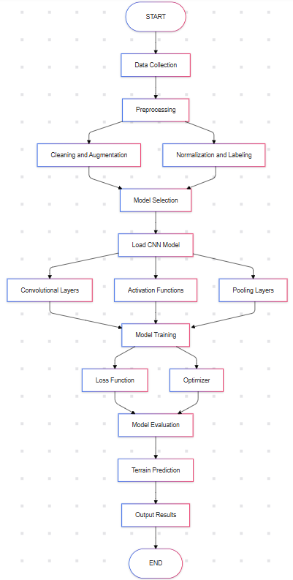

**Claims**

1. **Classification of images-** Classify different terrain types (e.g., mountains, forests, rivers, deserts) based on satellite or aerial images.

**2. Predictions from images-** Achieve high accuracy and robustness in the predictions across varying image resolutions and conditions.

1. **Provide scalable solution-** Provide a scalable solution that can be applied to real-time applications like autonomous vehicle navigation and disaster management.

**Technology Used:**

These technologies enable efficient processing, model training, and user interaction through a web application.

**Deep Learning Frameworks:**

**TensorFlow**: Used for building and training the Convolutional Neural Network (CNN). It supports large-scale training and GPU acceleration.

**PyTorch**: Utilized for research purposes due to its dynamic computational graph, allowing for easier experimentation and debugging.

**Data Processing Libraries:**

**NumPy**: Handles numerical operations and large datasets efficiently.

**Pandas**: Simplifies data manipulation and analysis, particularly for cleaning and organizing data.

**OpenCV**: Used for image processing tasks, such as resizing and augmenting satellite images.

**Web Application Technologies**

**Frontend**: Built using HTML, CSS, and JavaScript to create an interactive and user-friendly interface.

**Backend**: Flask serves as the backend framework, handling requests and processing input data.

**Bootstrap**: Used for responsive design, ensuring the web application is mobile-friendly.

**Visualization Tools**

**Matplotlib**: For visualizing training metrics like accuracy and loss.

**Plotly**: Provides interactive visualizations for displaying classification results on the web interface.

**Hardware: GPUs**

NVIDIA GPUs are employed to accelerate the training of deep learning models, significantly reducing training time by enabling parallel processing of data.

**Abstract**

Terrain prediction is a critical task in fields like autonomous navigation, disaster response, and environmental management. Traditional methods for terrain analysis rely on manual interpretation, which is labour-intensive, error-prone, and impractical for large-scale or real-time applications. This invention introduces an automated system that leverages convolutional neural networks (CNNs) to analyse satellite and aerial imagery for terrain classification and prediction with high accuracy. The system is designed to process large datasets efficiently, enabling faster and more reliable decision-making in scenarios where precision and speed are essential.

By utilizing advanced machine learning techniques, this model overcomes the limitations of manual analysis and enhances scalability and accuracy. The system can identify various terrain features, such as vegetation, water bodies, and urban structures, making it applicable across diverse industries. With its ability to integrate into existing workflows, this solution not only reduces human effort but also opens new possibilities for real-time terrain analysis, aiding in rapid disaster response, autonomous vehicle navigation, and large-scale environmental monitoring.

**End users**

The primary end users of this project include organizations and industries requiring precise terrain analysis, such as disaster management agencies, autonomous vehicle developers, environmental monitoring organizations, urban planners, and defence sectors. Additionally, geospatial analysts and researchers who work with large-scale satellite or aerial imagery will benefit from the system's ability to automate terrain prediction with high accuracy and efficiency.

**Advantage**

* Improved Accuracy: The use of convolutional neural networks (CNNs) ensures high accuracy in terrain classification, minimizing human error and improving decision-making.
* Scalability: The system can process large-scale datasets efficiently, making it suitable for extensive geographical areas and real-time applications.
* Time Efficiency: Automating terrain analysis significantly reduces the time required for manual interpretation, enabling faster responses in critical situations.
* Cost-Effective: By eliminating the need for manual labor and reducing errors, the system lowers operational costs in tasks like mapping, monitoring, and analysis.
* Versatility: The solution can be applied across various industries, including autonomous navigation, environmental monitoring, and disaster management, offering wide-ranging benefits.

**Conclusion**

This project presents an innovative solution for automated terrain prediction using convolutional neural networks (CNNs), offering a more efficient, accurate, and scalable approach compared to traditional manual methods. By leveraging advanced machine learning techniques, the system enhances the speed and precision of terrain analysis, making it ideal for applications in autonomous navigation, disaster response, and environmental monitoring. This invention not only reduces the dependency on human effort but also opens up new possibilities for real-time, large-scale terrain classification, ultimately improving decision-making and operational efficiency across various industries.

**Authors Lists**

|  |  |  |
| --- | --- | --- |
| **NAME** | **EMAIL** | **E-SIGN** |
| Himanshu Singh | [himanshu.2226cs1070@kiet.edu](mailto:himanshu.2226cs1070@kiet.edu) |  |
| Krishna Kant Gupta | [krishna.2226cs1088@kiet.edu](mailto:krishna.2226cs1088@kiet.edu) |  |
| Sanidhya Singh | [sanidhya.2226cs1146@kiet.edu](mailto:sanidhya.2226cs1146@kiet.edu) |  |